Moduldokumentation

Modul Applikationssicherheit (apsi)

Simon Wächter

2019

Inhalt

1 Einleitung 4

1.1 Einleitung 4

1.2 Lernziele 4

1.3 Prüfungen 4

2 Woche 1 5

2.1 Agenda 5

2.2 Administrative Issues 5

2.3 Who is Your Lecturer (Wagner) 5

2.4 whoami (Schläpfer) 6

2.5 Why is Application Security Important? 6

2.6 Lecture Overview (1) 7

2.7 Lecture Overview (2) 7

2.8 Lecture Overview (3) 8

2.9 Example: Buffer Overflow 8

2.10 How does a Buffer Overflow Work? 8

2.11 Buffer Overflow Demo 9

2.12 Not Really a Fix for Buffer Overflow: Stack Protection 9

2.13 Fix for Buffer Overflow: Checked Buffers 9

2.14 Example: Taint Checking in Perl (1) 10

2.15 Example: Taint Checking (2) 10

2.16 Example: Taint Checking (3) 11

2.17 Example: Taint Checking (4) 11

2.18 Example: Data Leakage by Behavior (1) 11

2.19 Example: Data Leakage by Behavior (2) 12

2.20 Example: Data Leakage by Error Output 12

2.21 Human Factors 13

2.22 Exercises and Preparation for Next Week 13

2.23 Reserve 13

3 Woche 2 14

3.1 Agenda 14

3.2 Recap: What do Attackers Want? 14

3.3 Buffer Overflow II 14

3.4 Buffer Overflow II 15

3.5 Buffer Overflow II 15

3.6 Buffer Overflow II 16

3.7 Buffer Overflow II 16

3.8 Attack Technique: Fuzzing 17

3.9 Error Handling 17

3.10 Case study – Handling too long input 18

3.11 Case-study: Compression Bomb 18

3.12 Error Handling 19

3.13 Algorithmic Complexity Attacks 20

3.14 Algorithmic Complexity: Sorting 20

3.15 Algorithmic Complexity: Hashing 21

3.16 Algorithmic Complexity: Regular Expressions 21

4 Woche 3 22

4.1 Agenda 22

4.2 Secure Coding Principle: Test-before-use 22

4.3 Input Validation 22

4.4 Input Normalization 23

4.5 Unix Permission Model (simplified) 23

4.6 Chroot 24

4.7 Mandatory Access Control (MAC) 24

4.8 MAC Example: SELinux 25

4.9 MAC Example: AppArmor 25

4.10 Secure Coding Principle: Defense in Depth 26

4.11 Privilege Separation 26

4.12 Overall Idea 27

4.13 Form of the Modules 27

4.14 Example: OpenSSH 28

4.15 OpenSSH: Privilege Separation Approach 28

4.16 Example: Postfix MTA (Email Server) 28

4.17 Postfix System View 29

4.18 Postfix: Example Data-Flow 29

5 Woche 4 30

5.1 Agenda 30

5.2 Security Testing (for Software) 30

5.3 Pen-Test 30

5.4 How does a Pen-Test fail? 31

5.5 Code Inspection and Review 31

5.6 Code Scanners 32

5.7 Execution Emulators 32

5.8 Patching 33

5.9 How to Patch 33

5.10 Problems with Patching 34

5.11 Problems with not Patching 34

5.12 Problems with Unavailability of Patches 34

5.13 Economic Aspects of Security 35

5.14 Case Study: DDoS on Brian Krebs (20.9.2016) 35

5.15 What can Perform Such an Attack? 35

5.16 IoT: Internet of insecure Things 36

5.17 Why are These IoT Devices so Insecure? 36

5.18 Possible Solutions 37

5.19 Does it Pay to make Software Secure? 37

5.20 So, what to do? 38

6 Woche 5 39

# Einleitung

## Einleitung

Dieses Dokument stellt die Moduldokumentation für das Modul apsi dar. Allfällige Unterlagen sind im Modulordner zu finden.

## Lernziele

Das Modul beinhaltet folgende Lernziele:

* Kennen typische Bedrohungen von Applikationen sowie ihren Daten und können abschätzen, wieweit diese für durch sie zu entwickelnde Software ein Sicherheitsrisiko darstellen
* Kennen typische Sicherheitsprobleme und können sie vermeiden
* Sind in der Lage, einschlägige Quellen zu konsultieren, um neu veröffentlichte Sicherheitsprobleme zu erfassen und zu verstehen, wie diese zu vermeiden sind
* Verfügen über Konzeptwissen, nicht nur Produktwissen, um das Gelernte auch in anderen Umfeldern und mit anderen Programmiersprachen anwenden zu können

## Prüfungen

Die Modulnote setzt sich zu 100% aus einer Semesterprüfung und einer Modulschlussprüfung zu je 50% zusammen.

# Woche 1

## Agenda

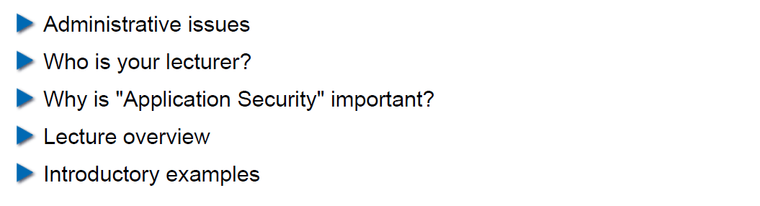

## Administrative Issues

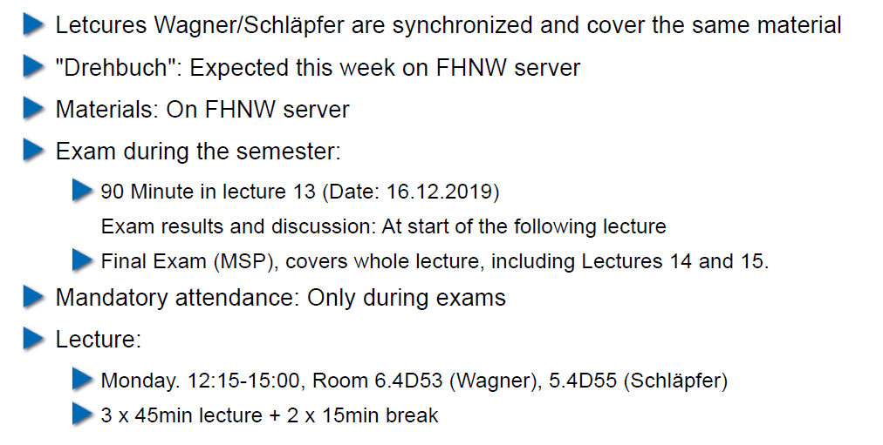

## Who is Your Lecturer (Wagner)

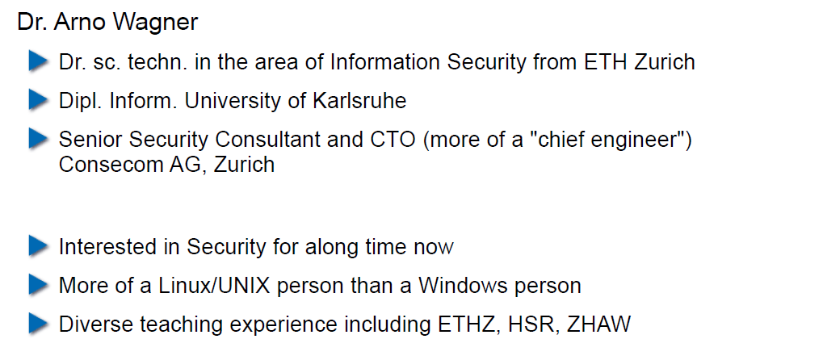

## whoami (Schläpfer)

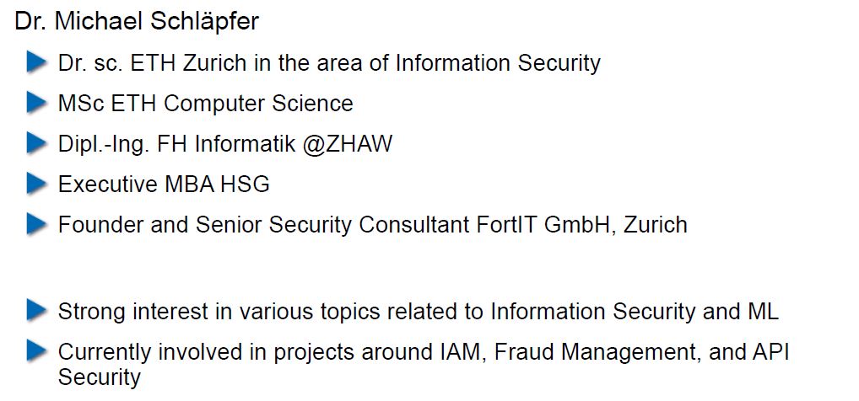

## Why is Application Security Important?

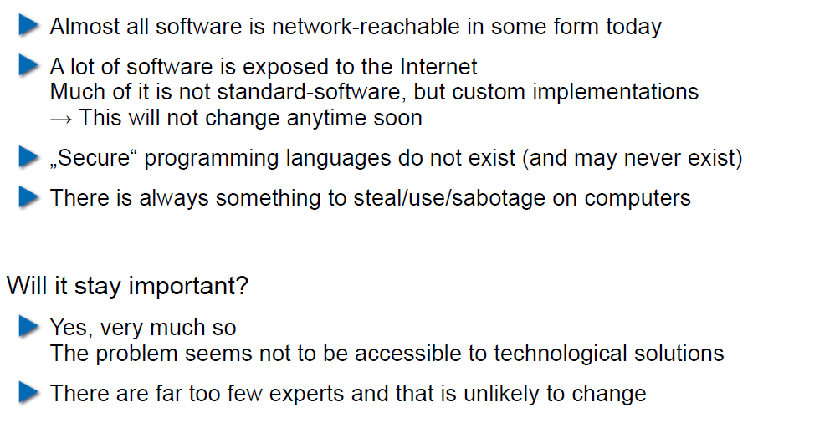

## Lecture Overview (1)

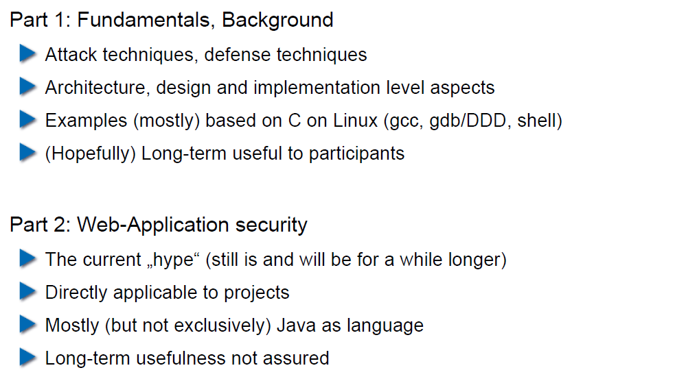

## Lecture Overview (2)

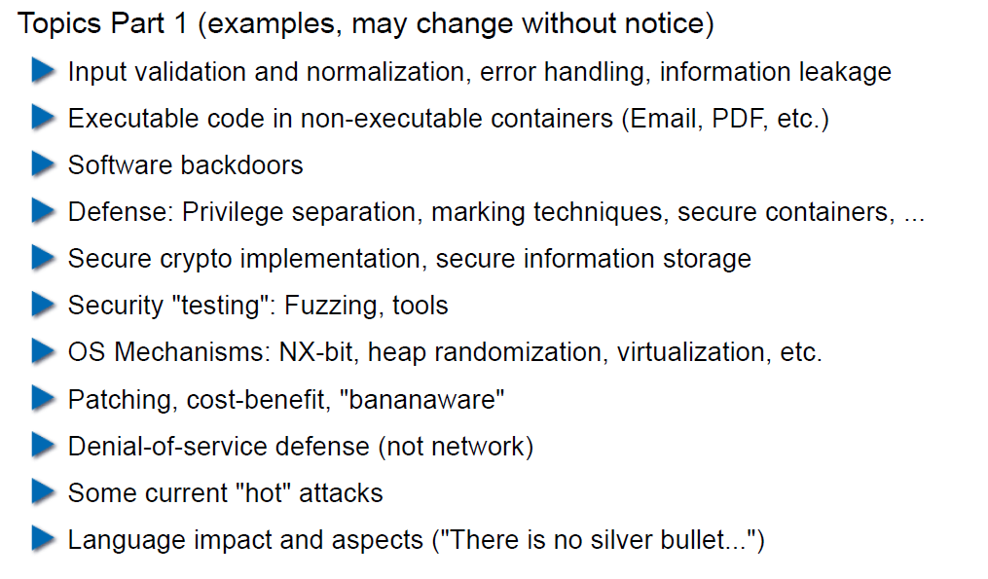

## Lecture Overview (3)

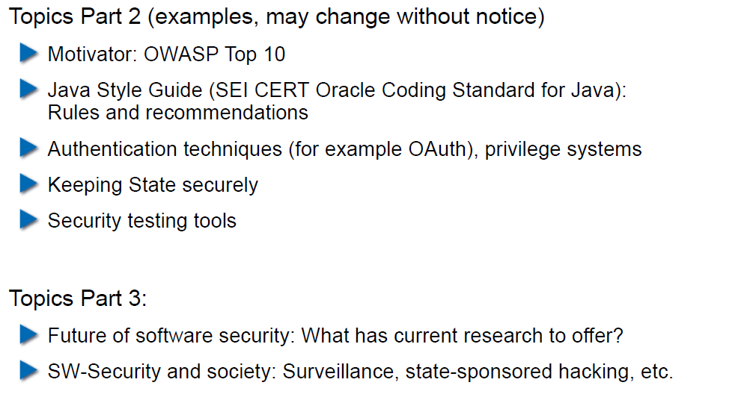

## Example: Buffer Overflow

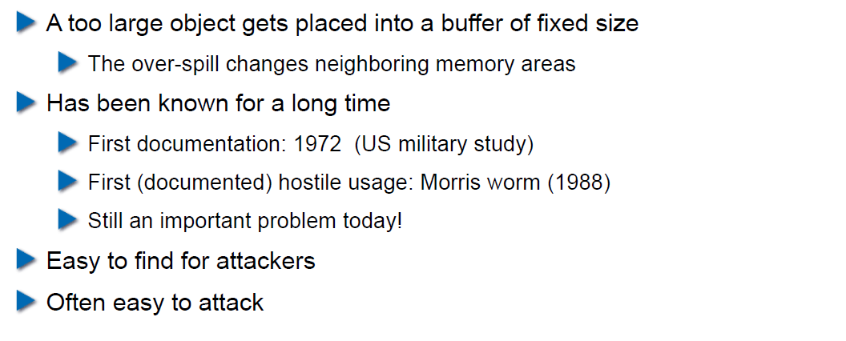

## How does a Buffer Overflow Work?

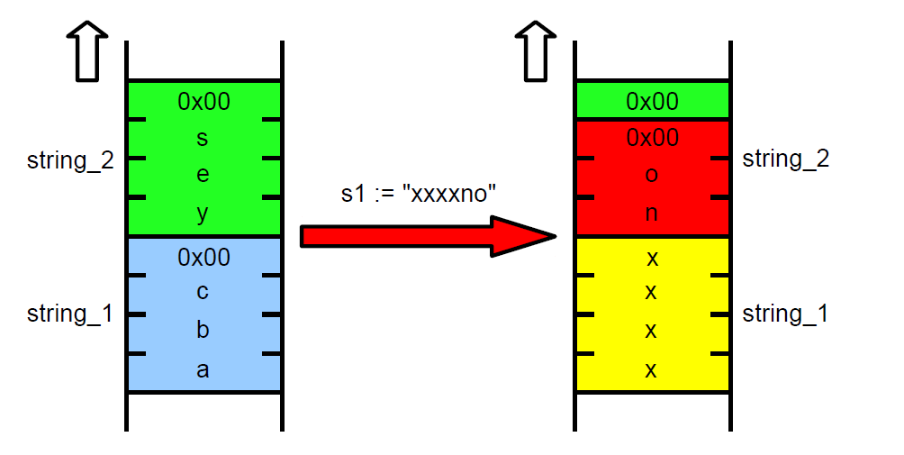

## Buffer Overflow Demo

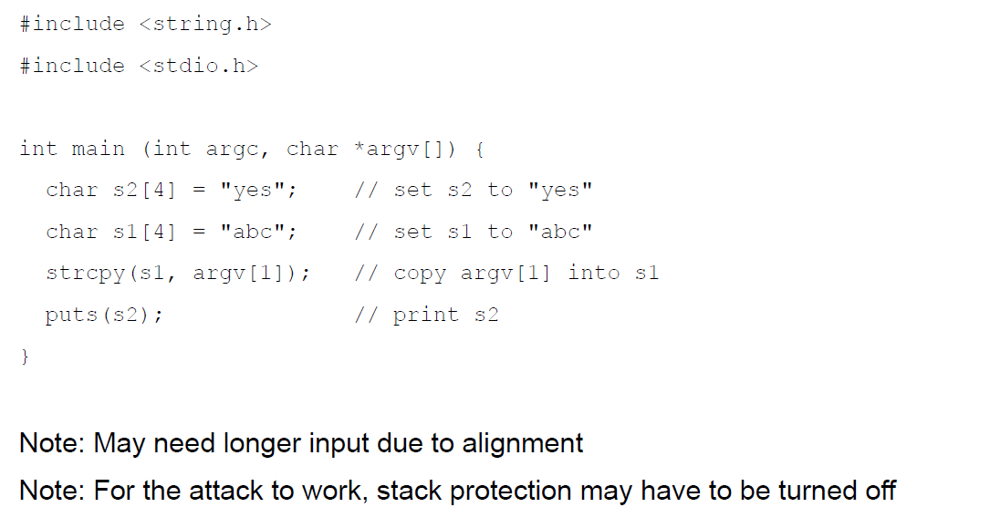

## Not Really a Fix for Buffer Overflow: Stack Protection

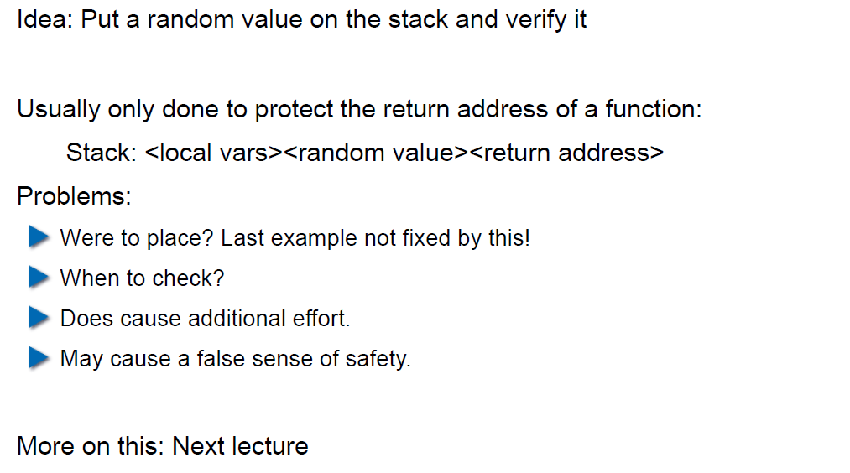

## Fix for Buffer Overflow: Checked Buffers

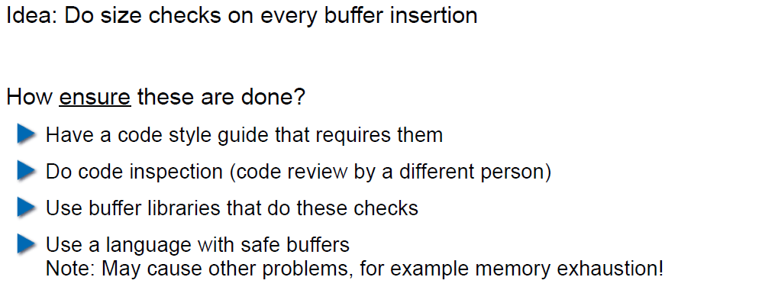

## Example: Taint Checking in Perl (1)

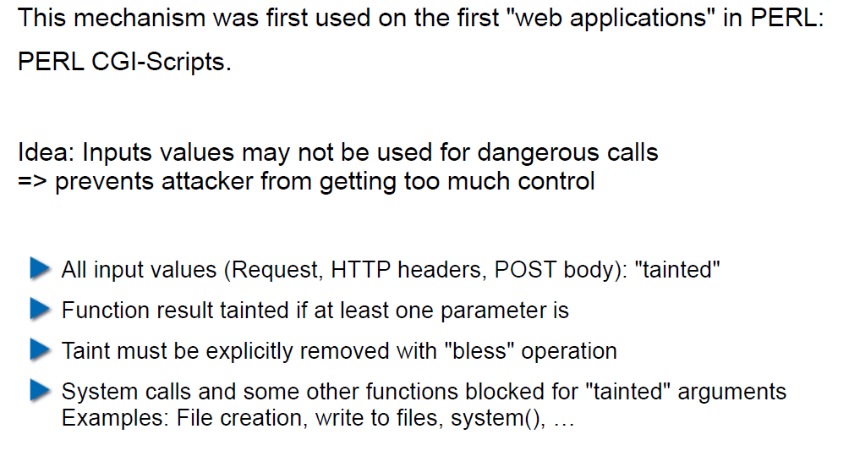

## Example: Taint Checking (2)

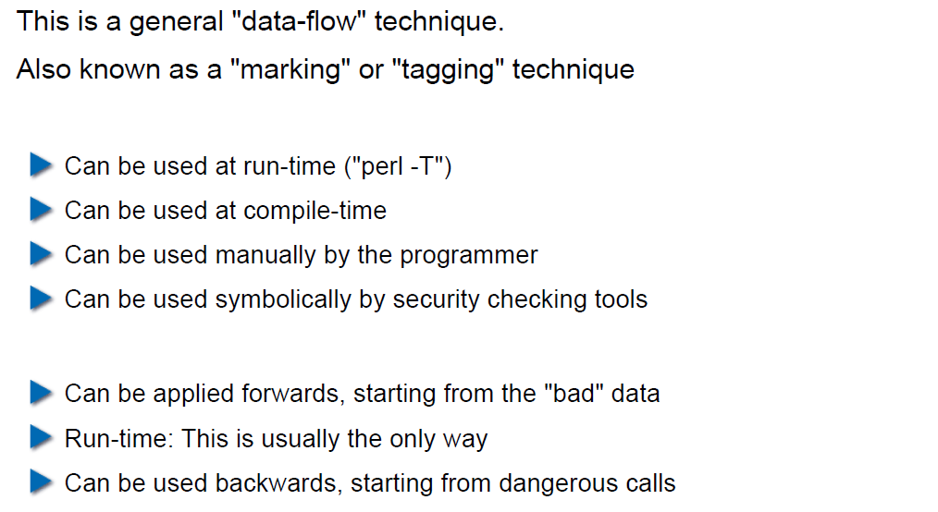

## Example: Taint Checking (3)

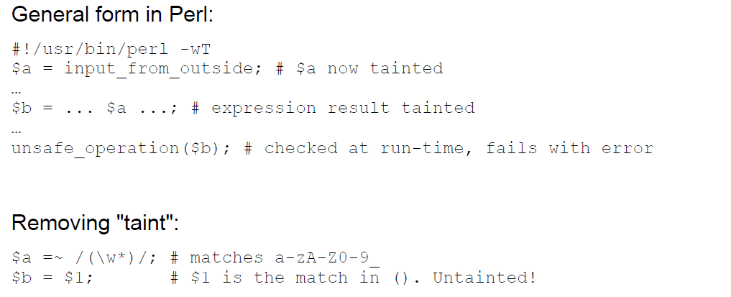

## Example: Taint Checking (4)

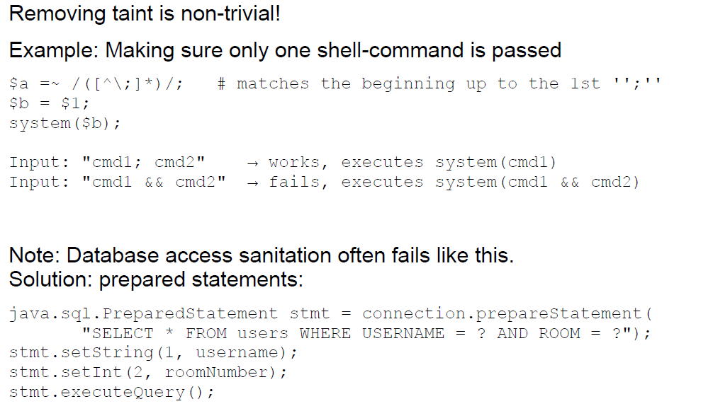

## Example: Data Leakage by Behavior (1)

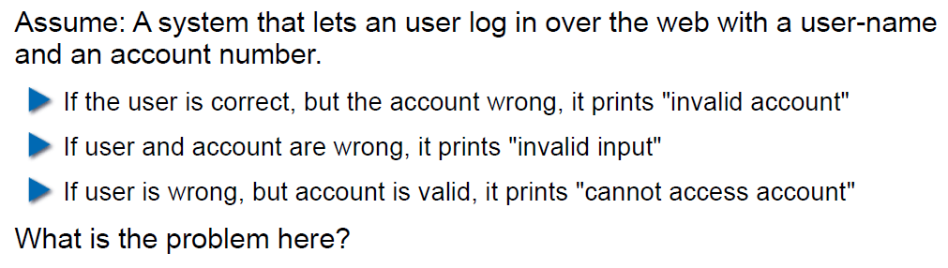

## Example: Data Leakage by Behavior (2)

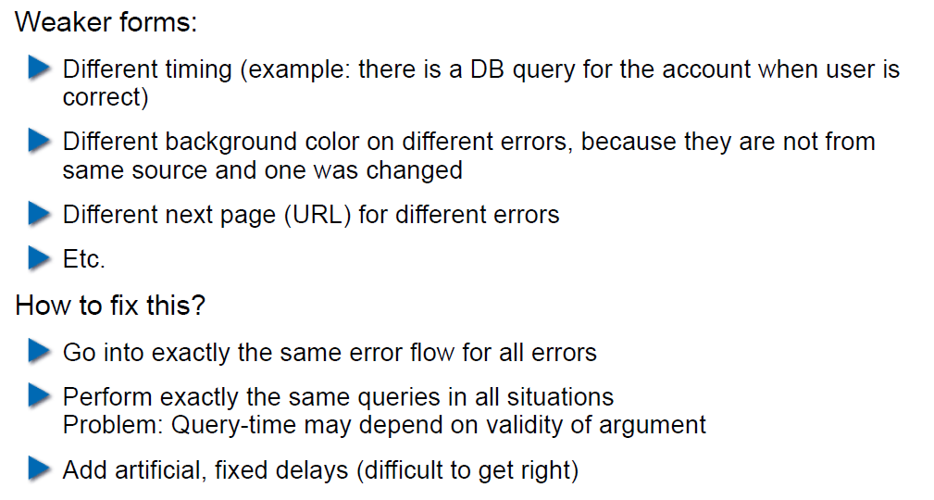

## Example: Data Leakage by Error Output

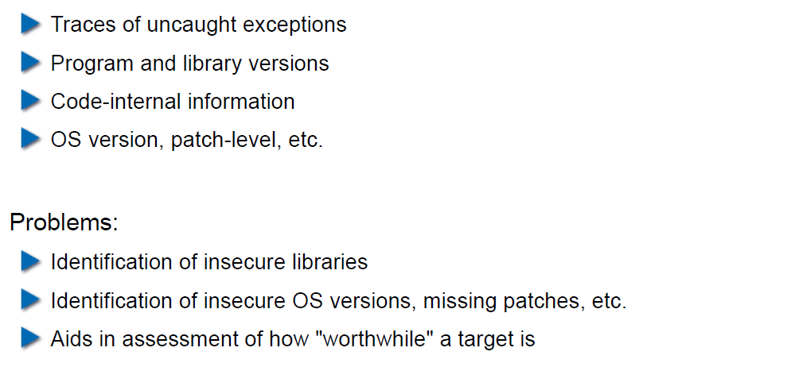

## Human Factors

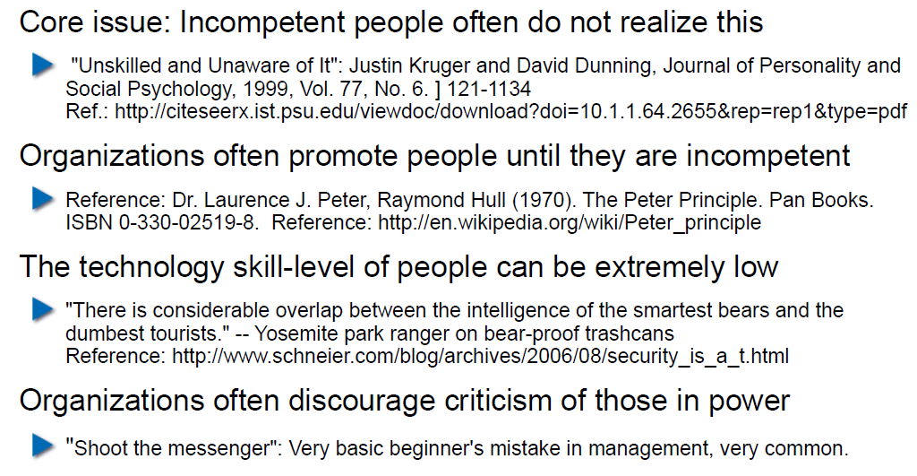

## Exercises and Preparation for Next Week

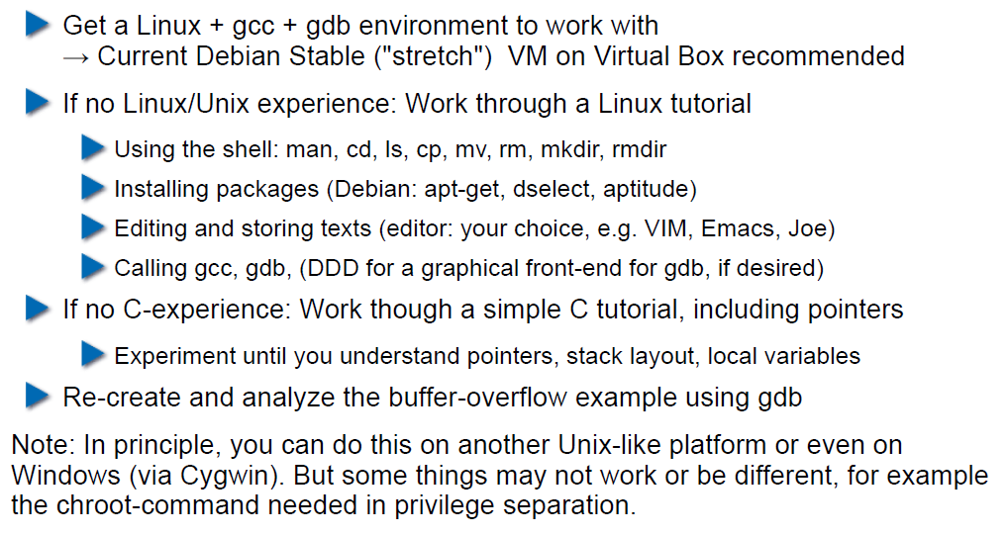

## Reserve

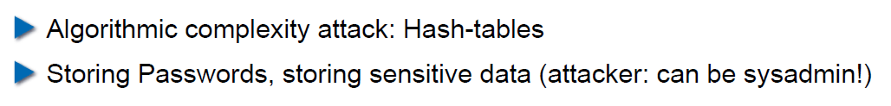

# Woche 2

## Agenda

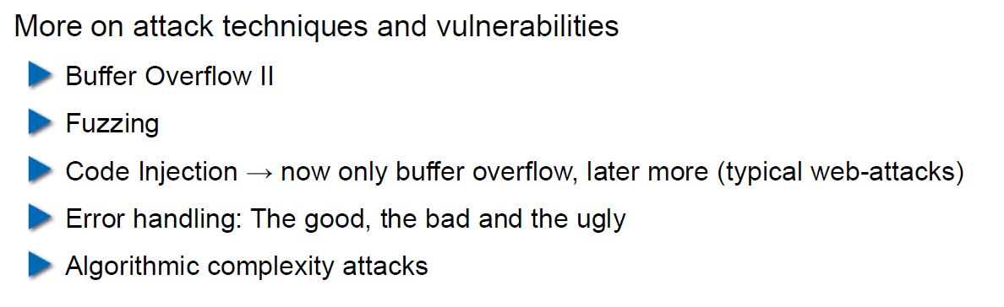

## Recap: What do Attackers Want?

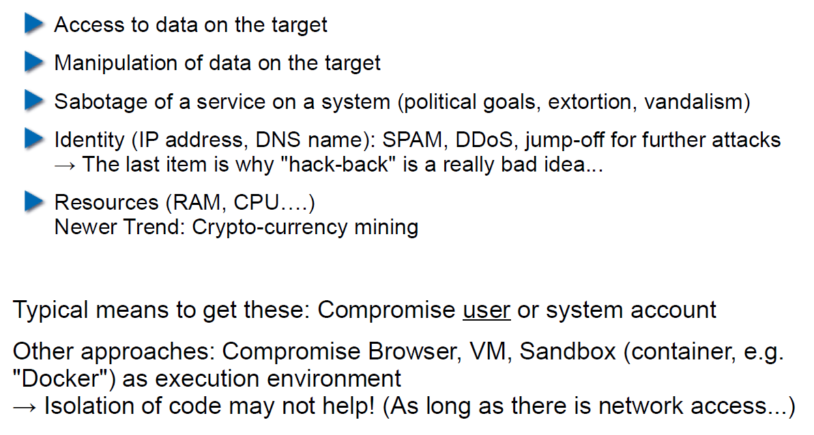

## Buffer Overflow II

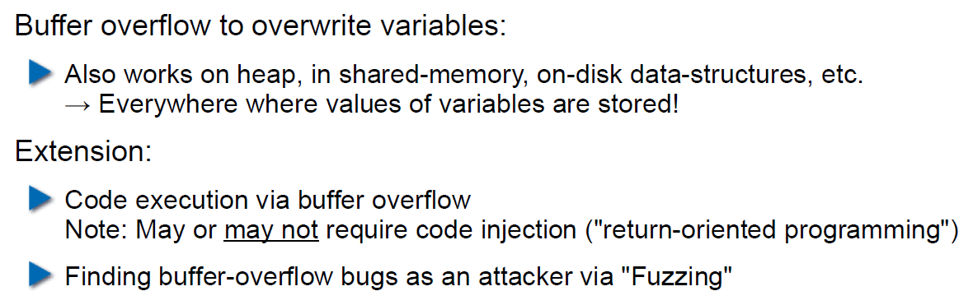

## Buffer Overflow II

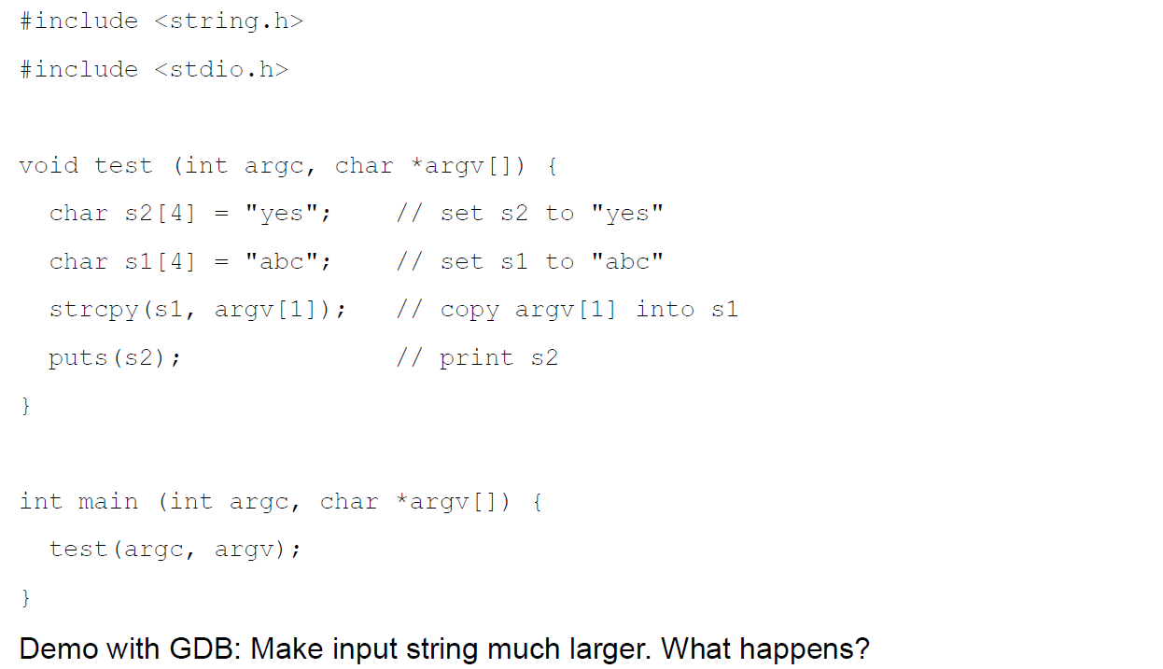

## Buffer Overflow II

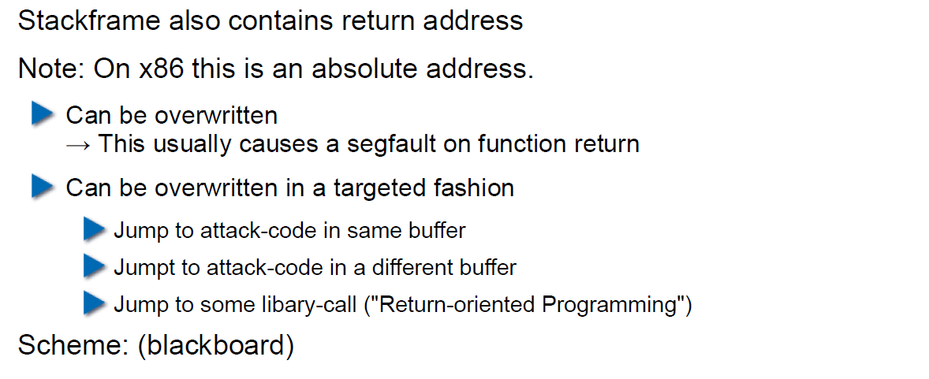

## Buffer Overflow II

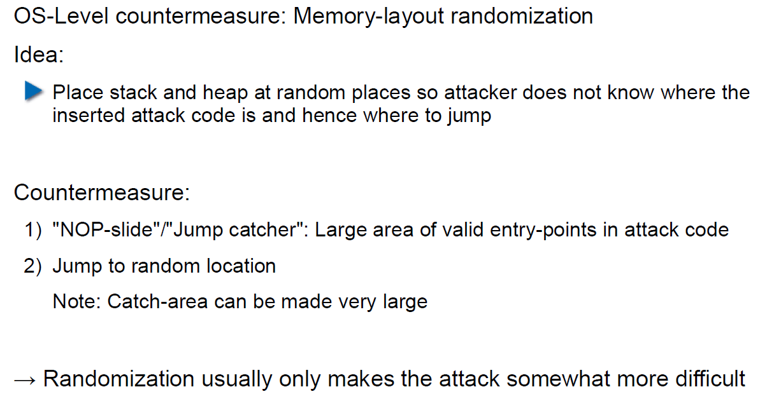

## Buffer Overflow II

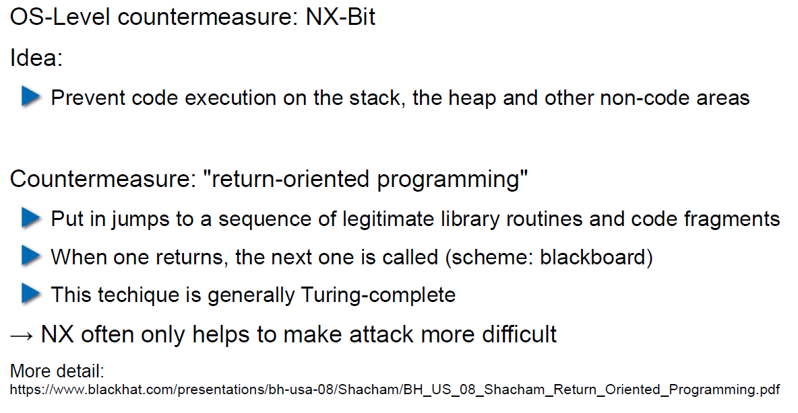

## Attack Technique: Fuzzing

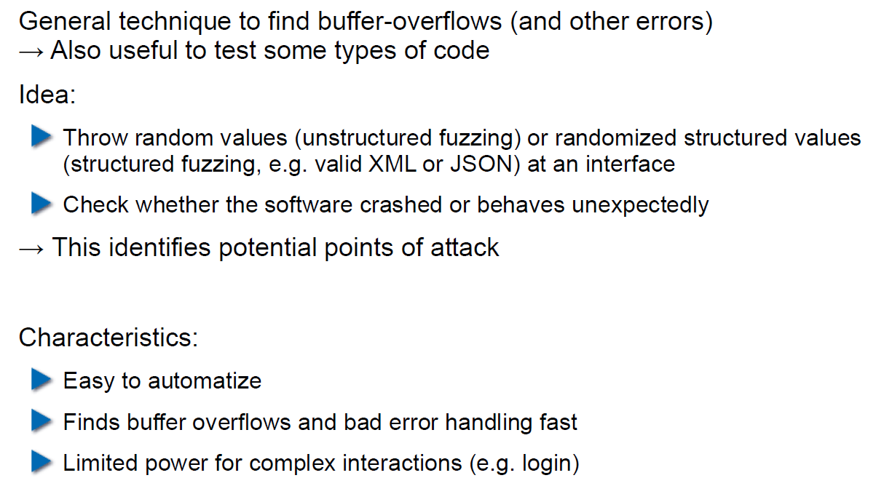

## Error Handling

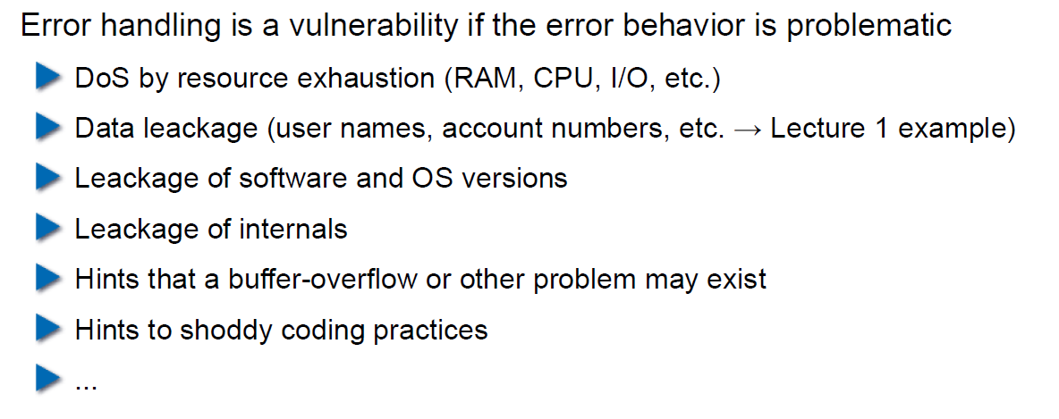

## Case study – Handling too long input

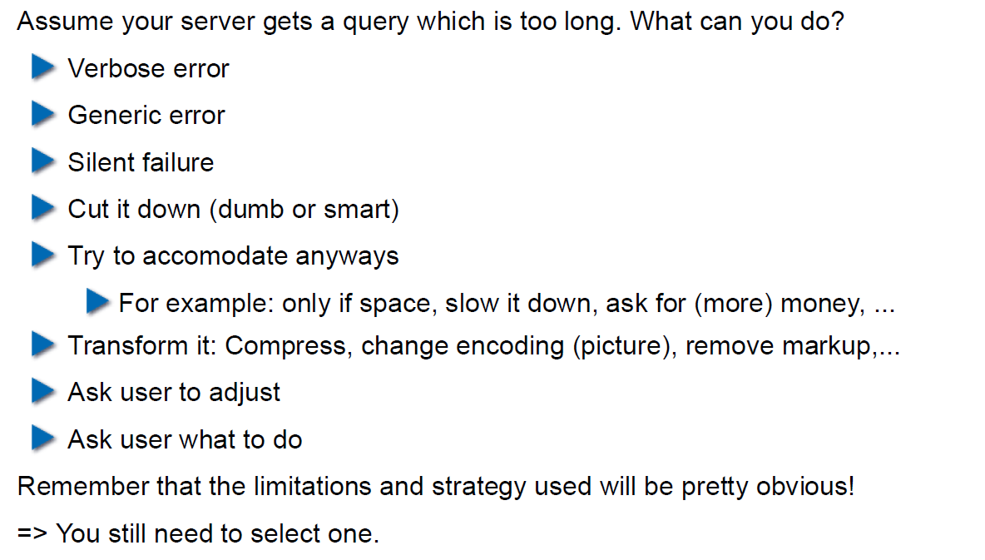

## Case-study: Compression Bomb

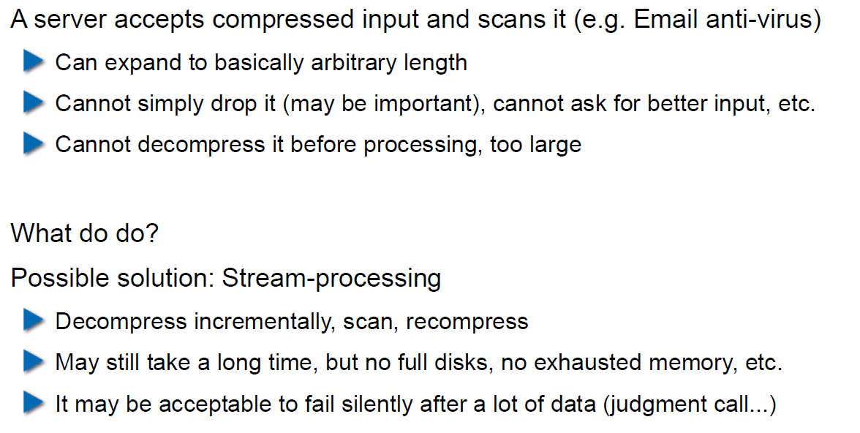

## Error Handling

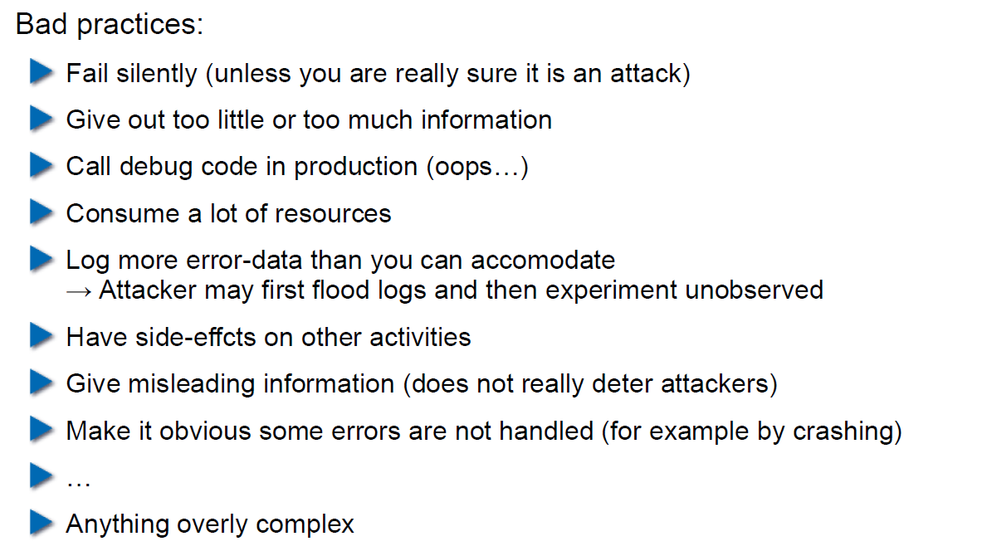

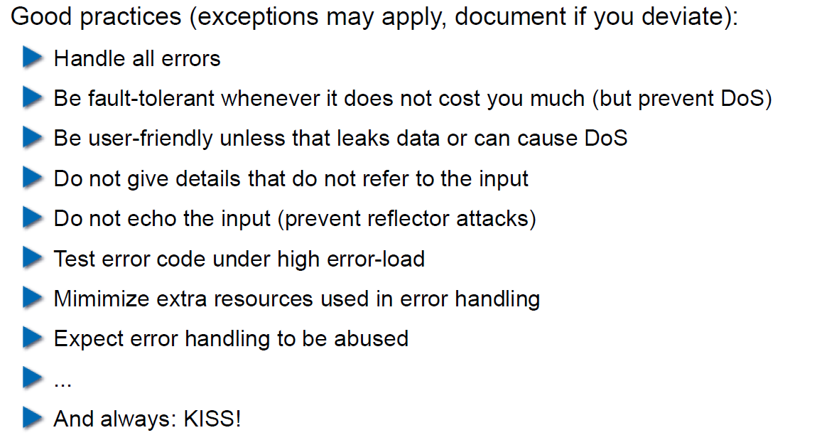

## Algorithmic Complexity Attacks

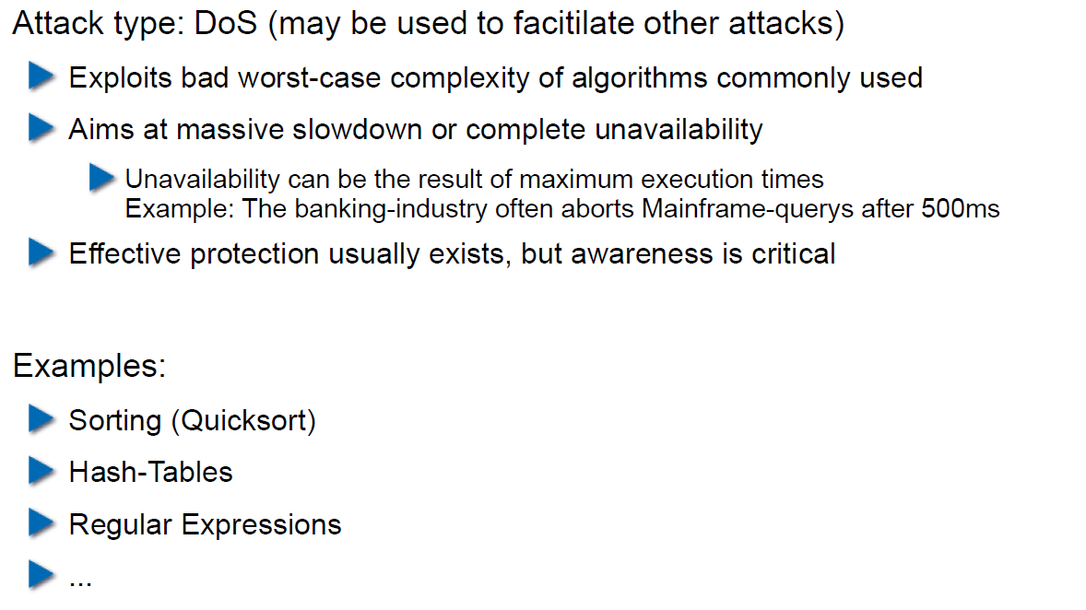

## Algorithmic Complexity: Sorting

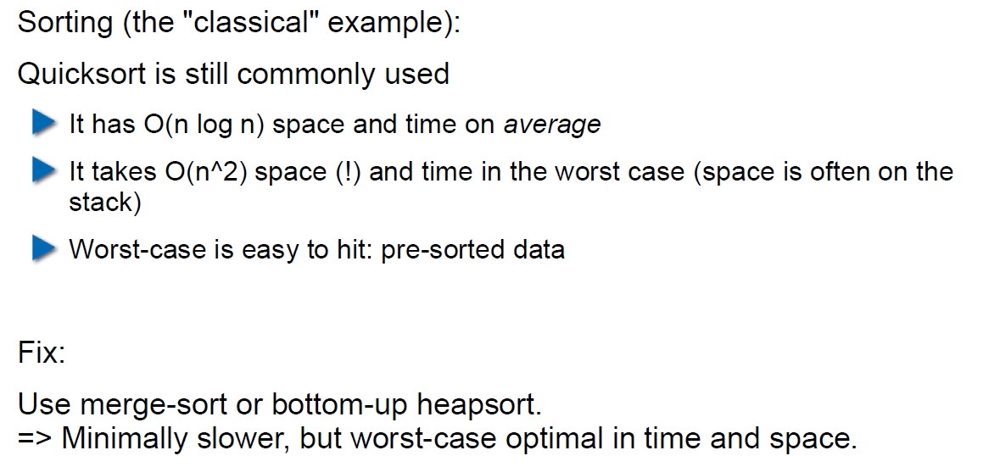

## Algorithmic Complexity: Hashing

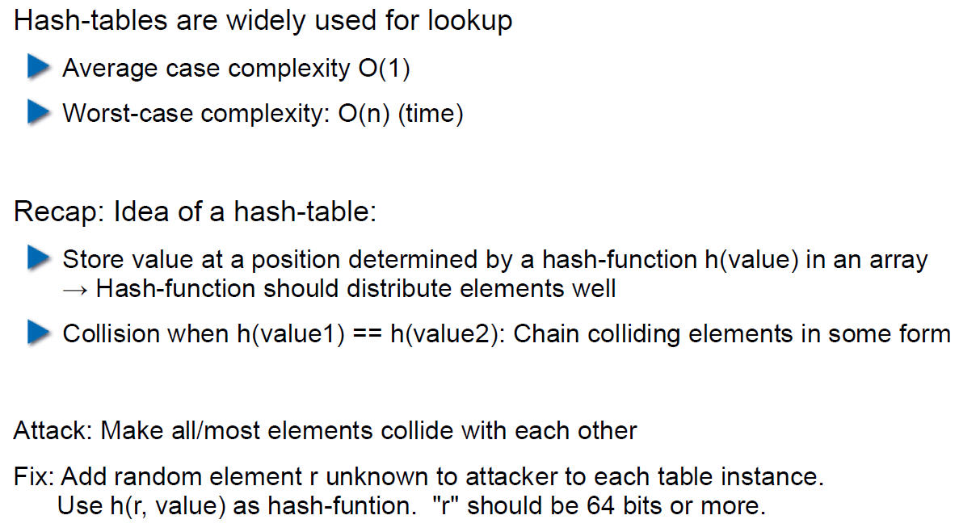

## Algorithmic Complexity: Regular Expressions

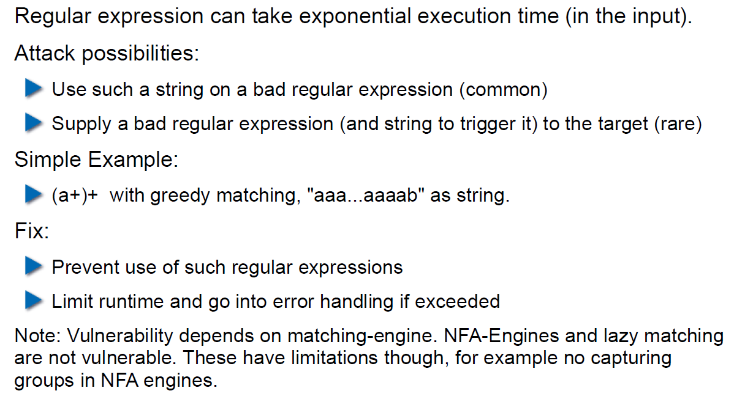

# Woche 3

## Agenda

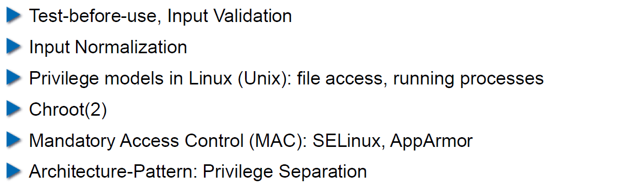

## Secure Coding Principle: Test-before-use

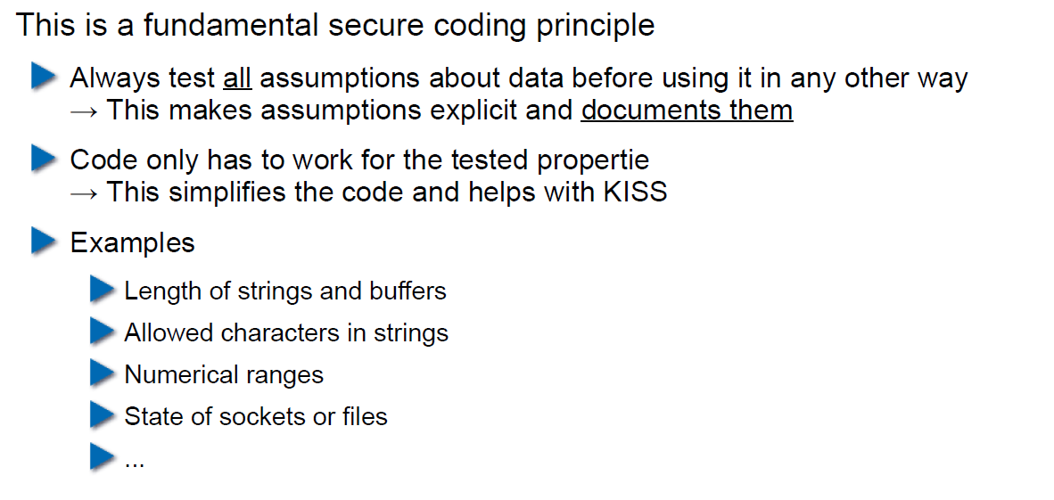

## Input Validation

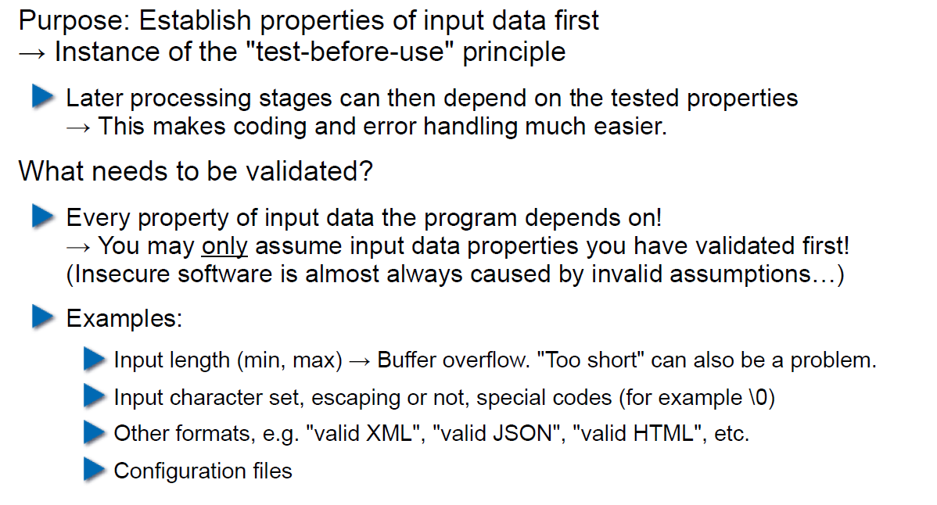

## Input Normalization

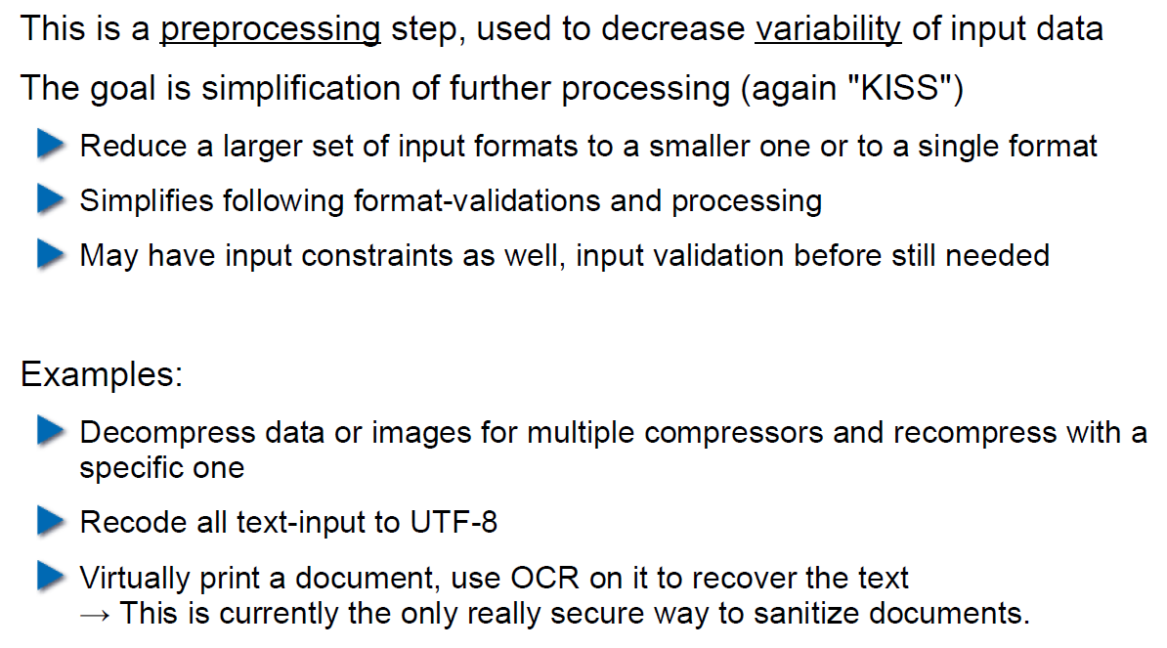

## Unix Permission Model (simplified)

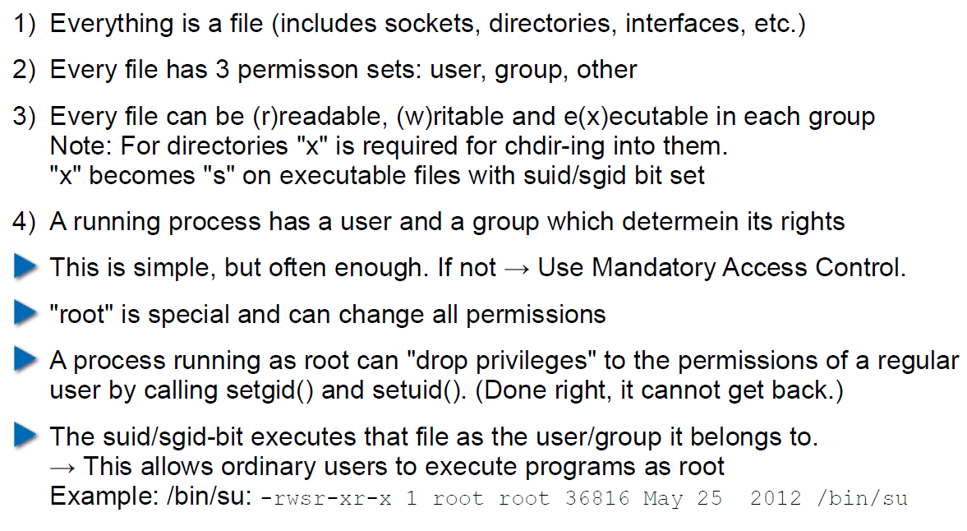

## Chroot

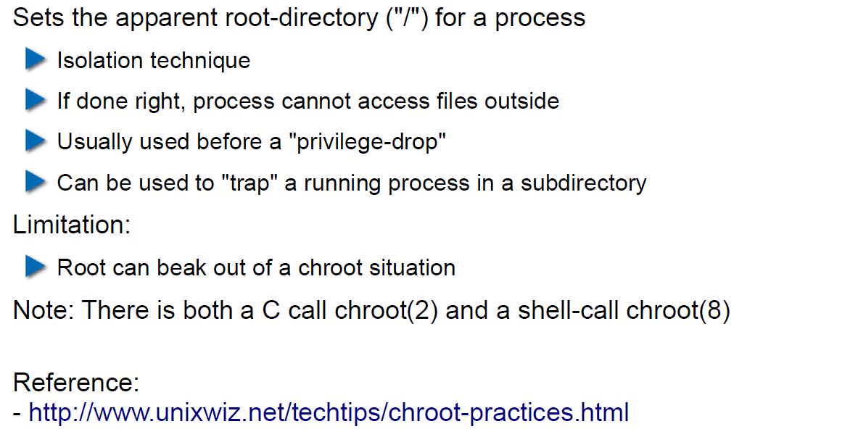

## Mandatory Access Control (MAC)

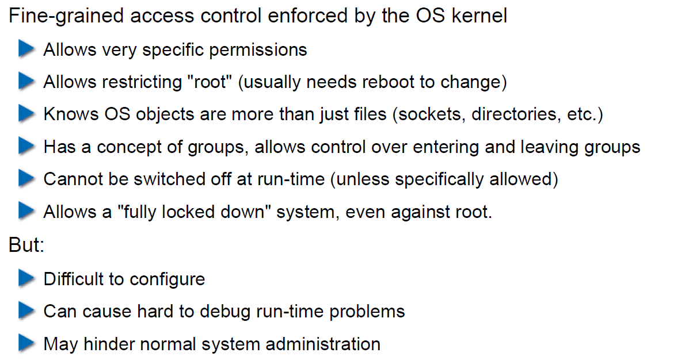

## MAC Example: SELinux

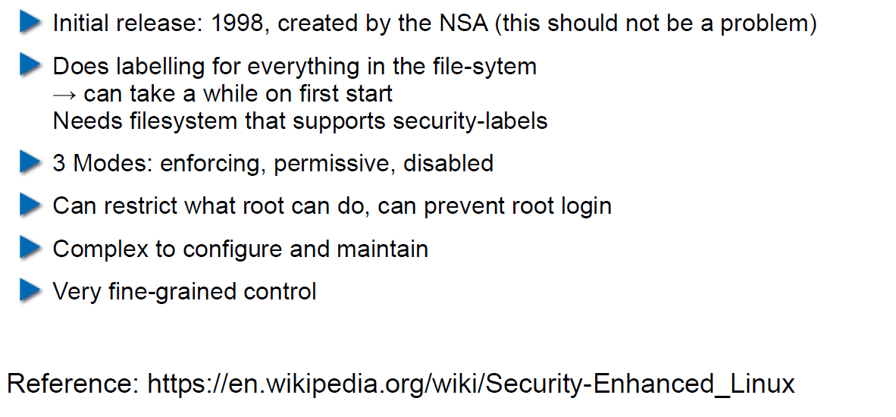

## MAC Example: AppArmor

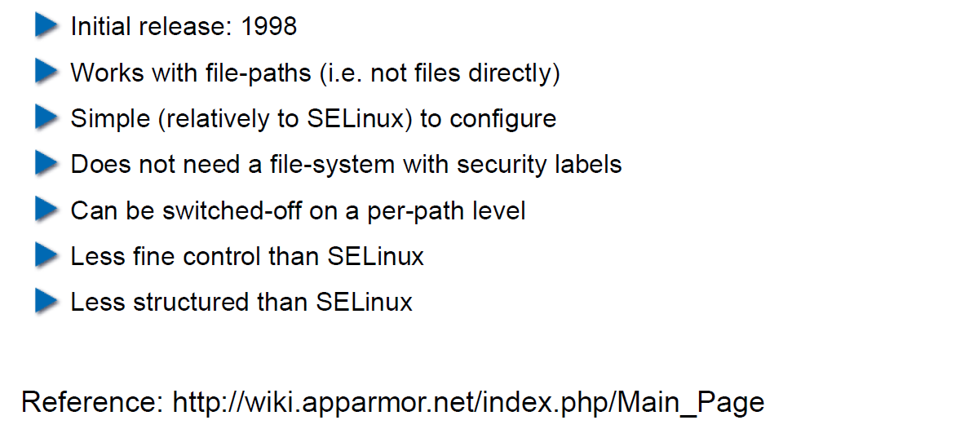

## Secure Coding Principle: Defense in Depth

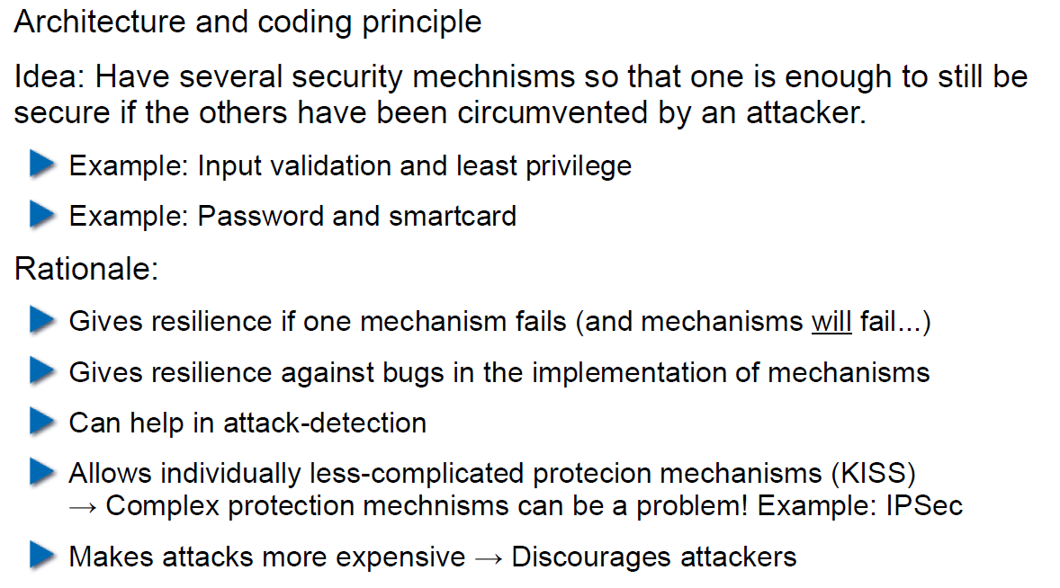

## Privilege Separation

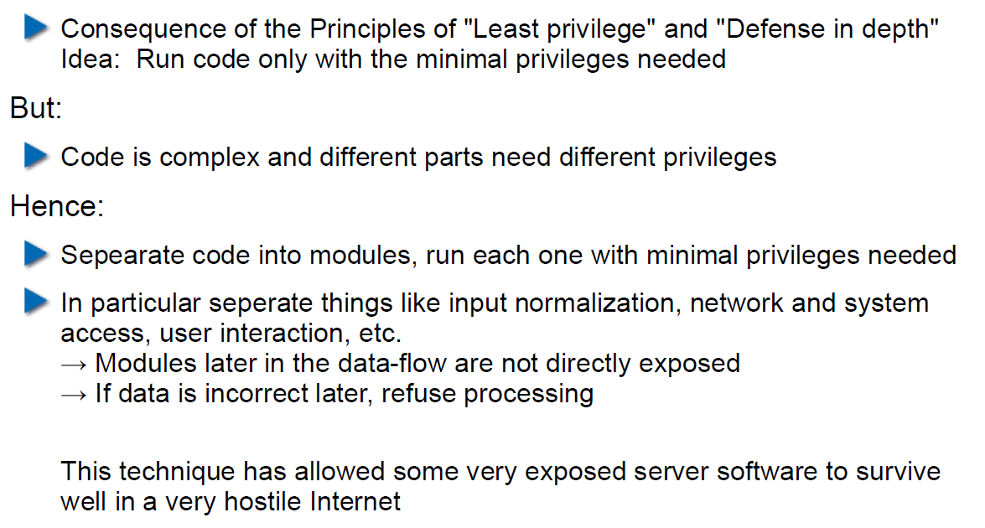

## Overall Idea

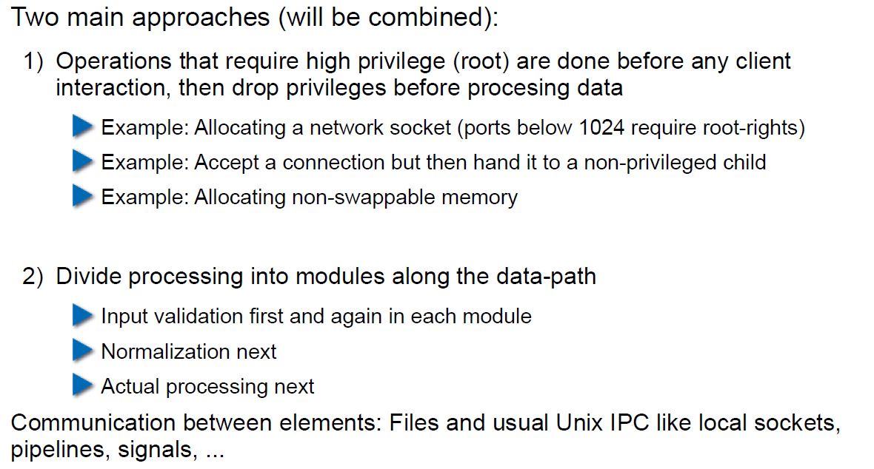

## Form of the Modules

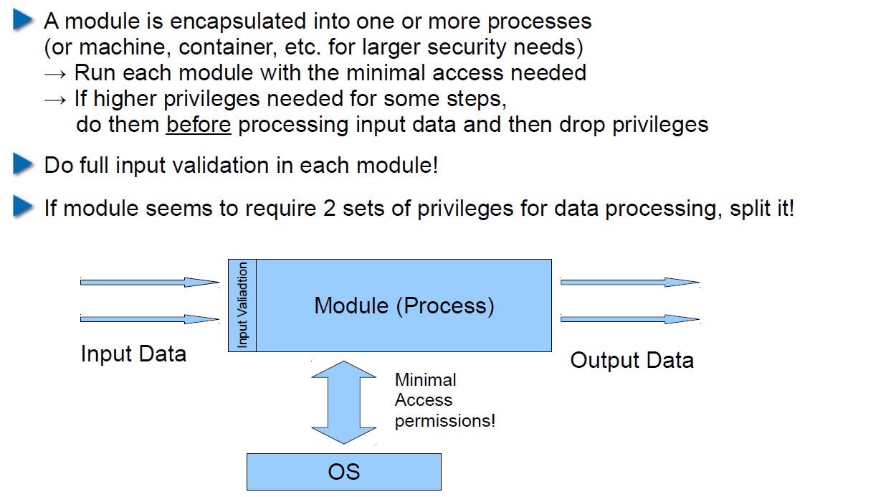

## Example: OpenSSH

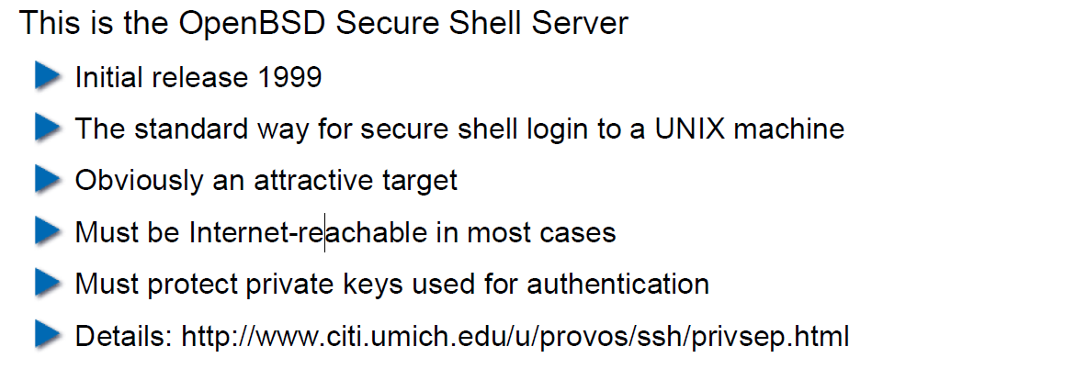

## OpenSSH: Privilege Separation Approach

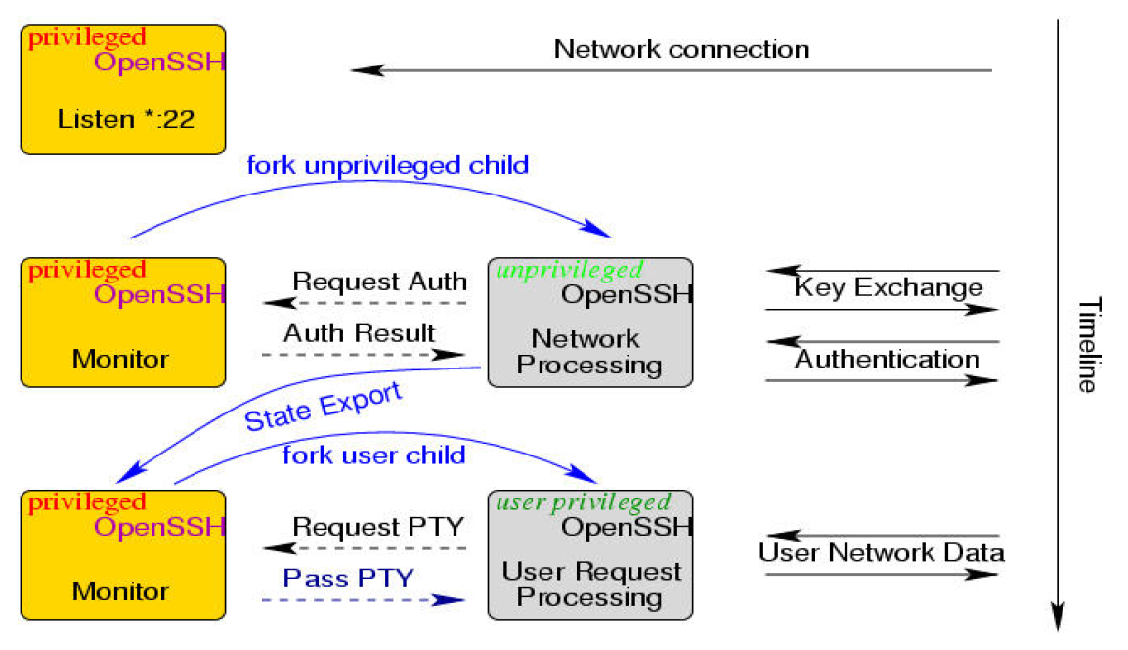

## Example: Postfix MTA (Email Server)

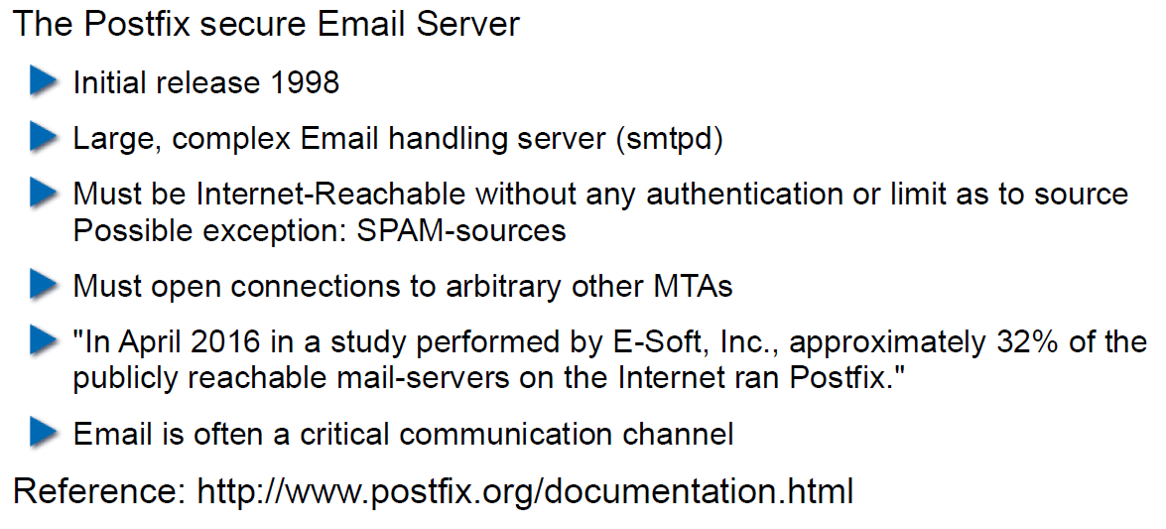

## Postfix System View

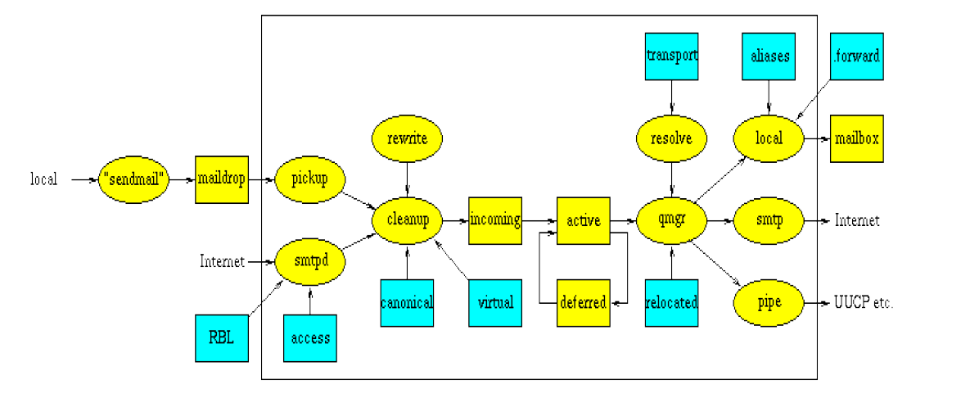

## Postfix: Example Data-Flow

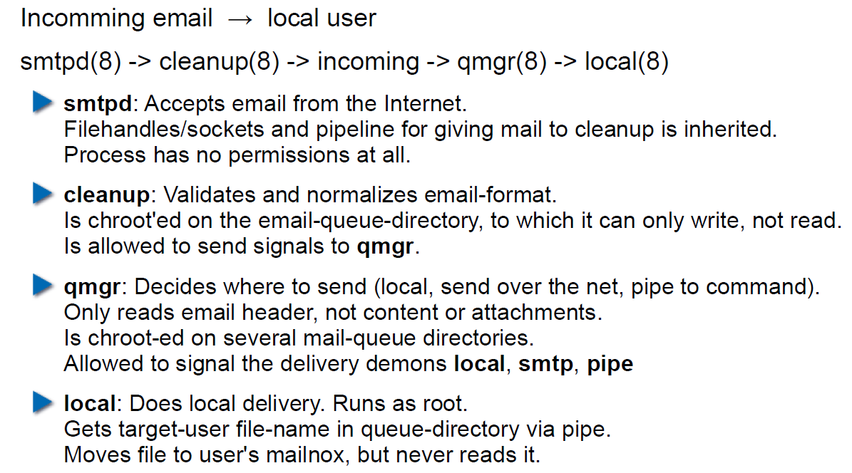

# Woche 4

## Agenda

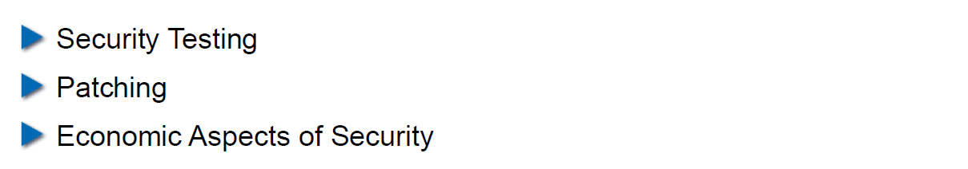

## Security Testing (for Software)

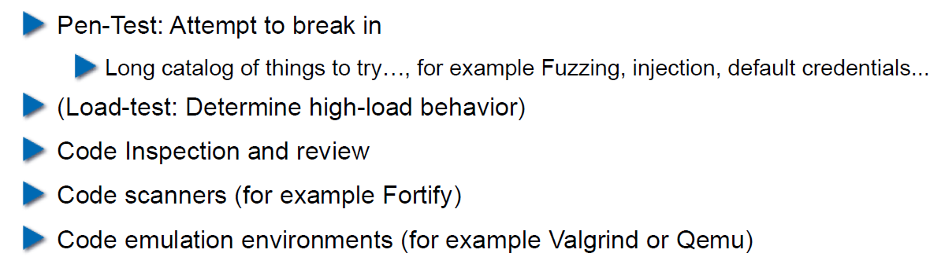

## Pen-Test

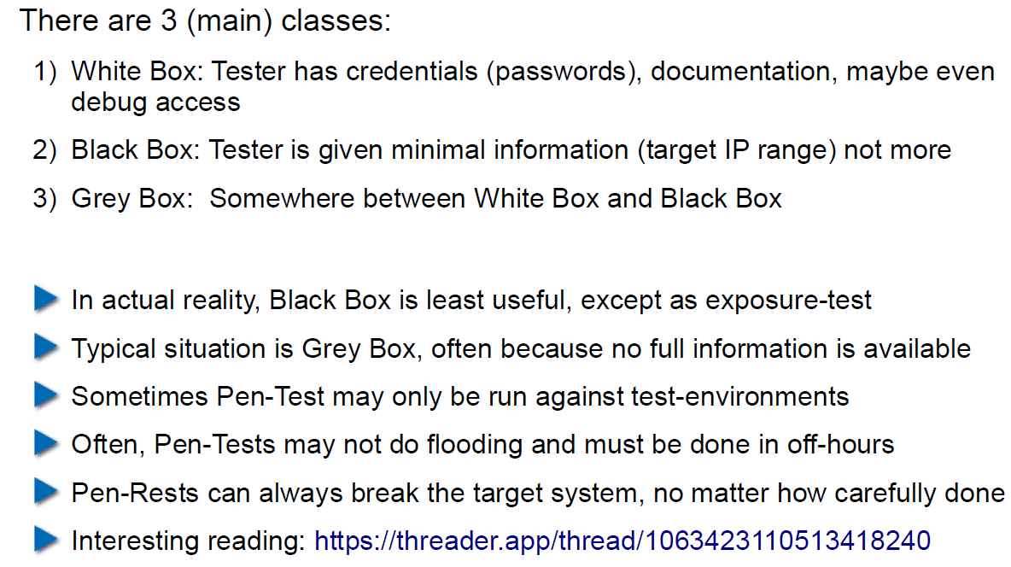

## How does a Pen-Test fail?

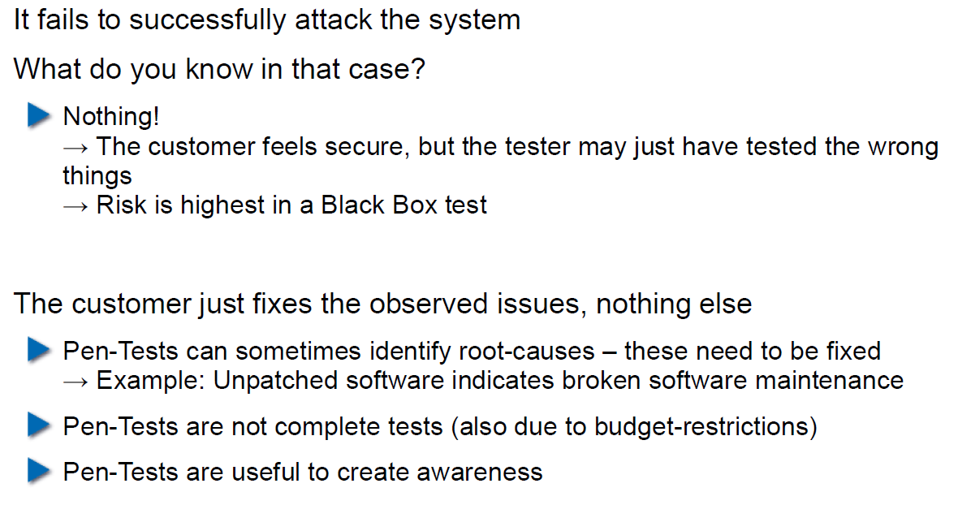

## Code Inspection and Review

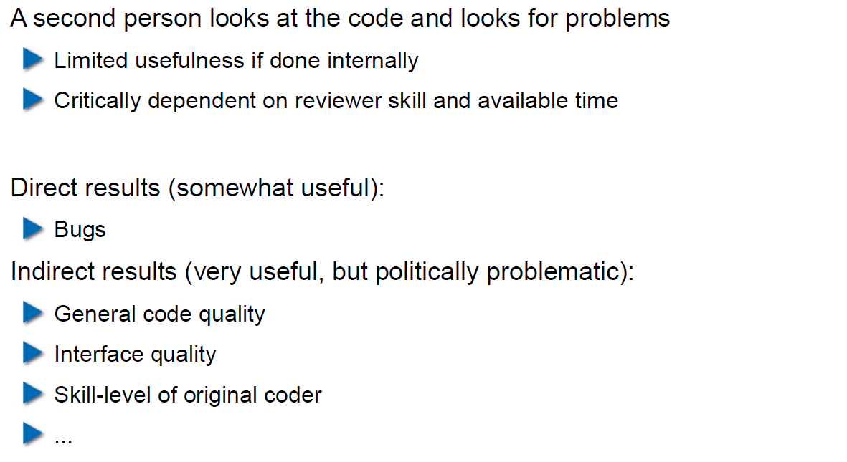

## Code Scanners

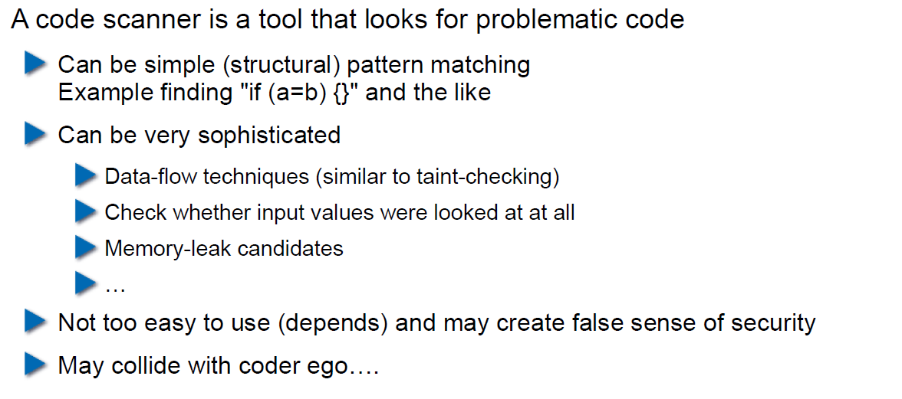

## Execution Emulators

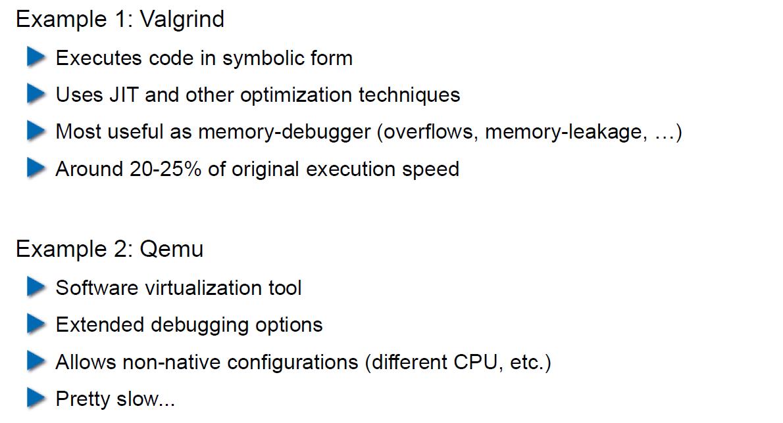

## Patching

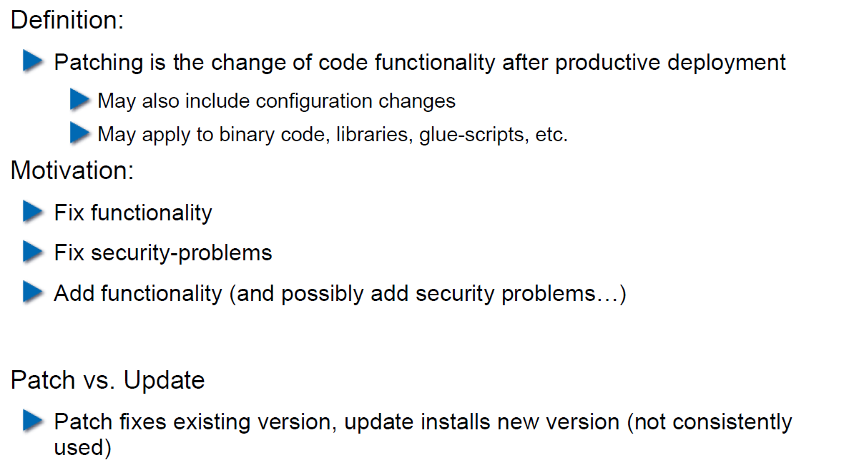

## How to Patch

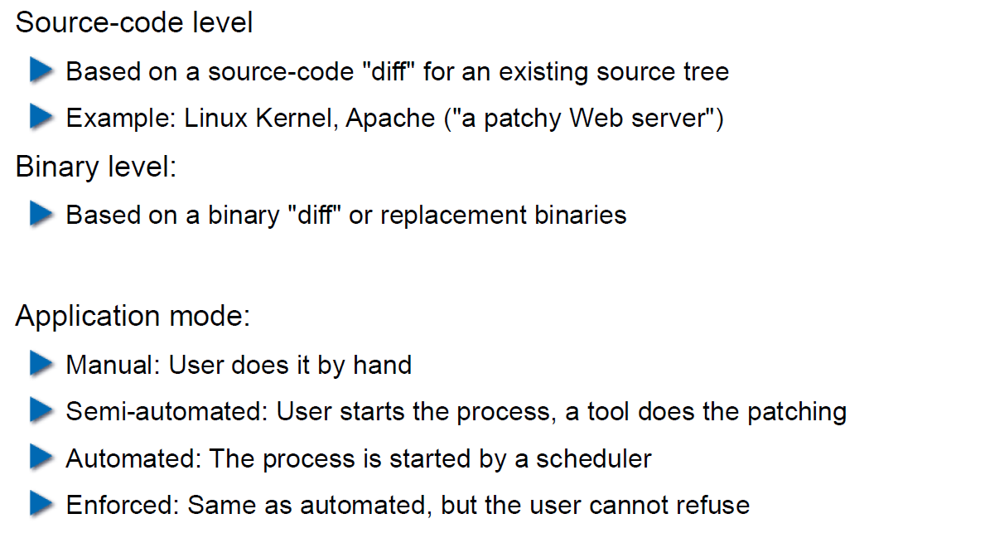

## Problems with Patching

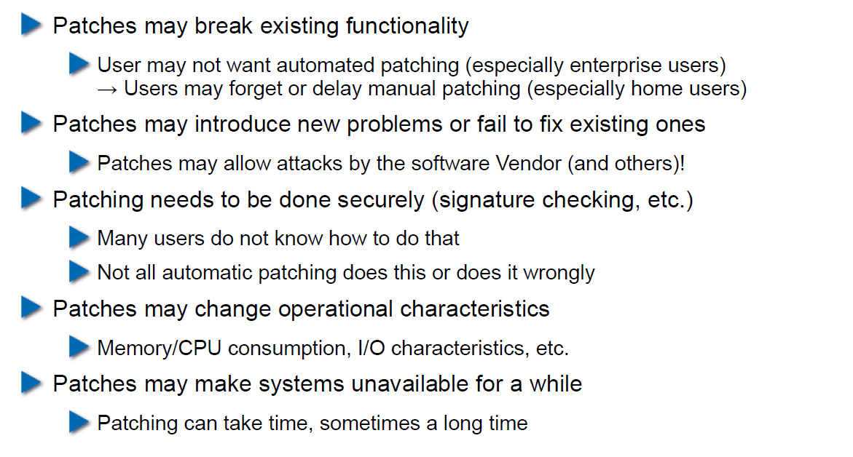

## Problems with not Patching

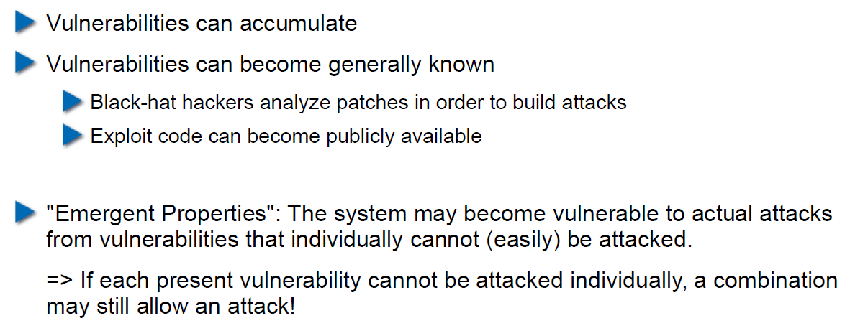

## Problems with Unavailability of Patches

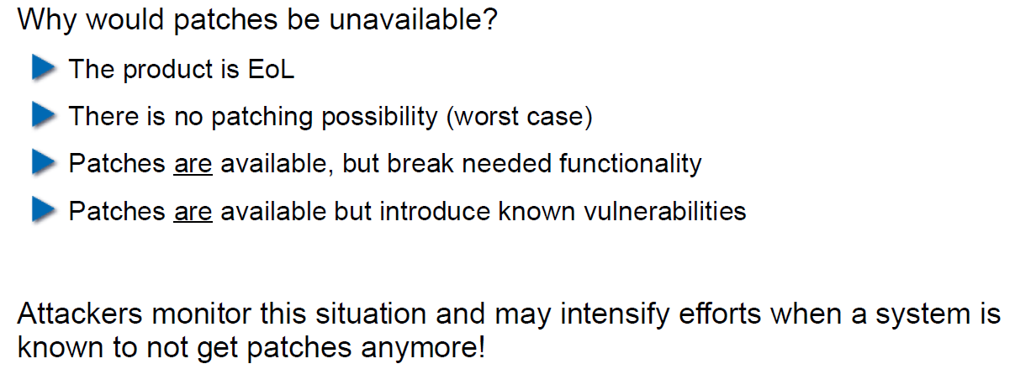

## Economic Aspects of Security

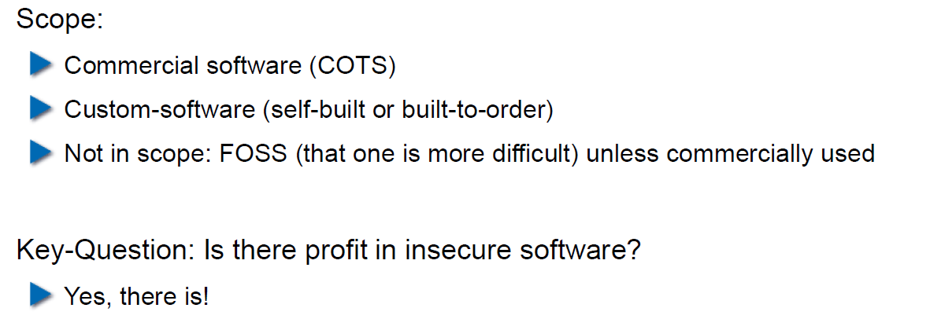

## Case Study: DDoS on Brian Krebs (20.9.2016)

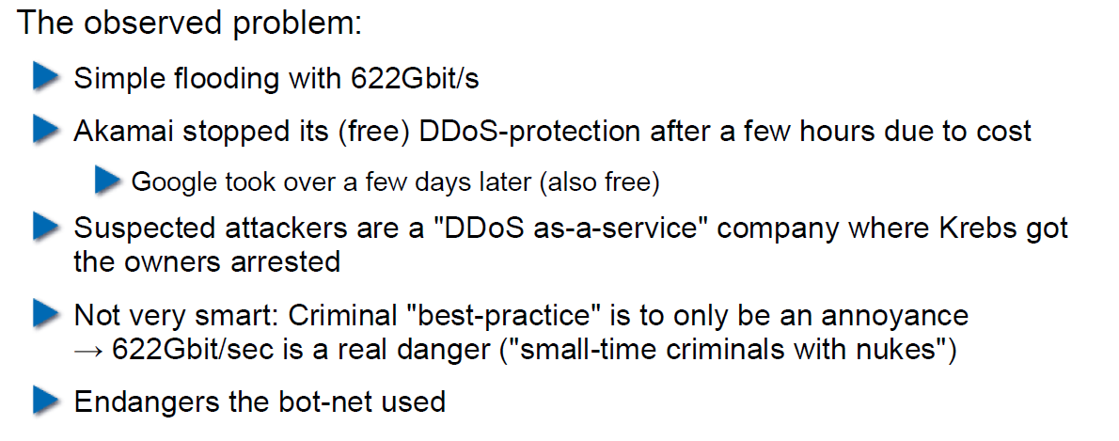

## What can Perform Such an Attack?

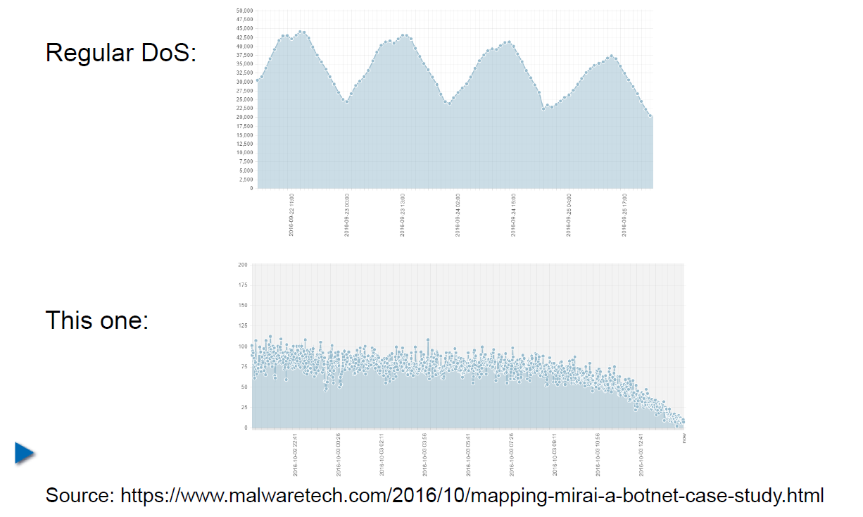

## IoT: Internet of insecure Things

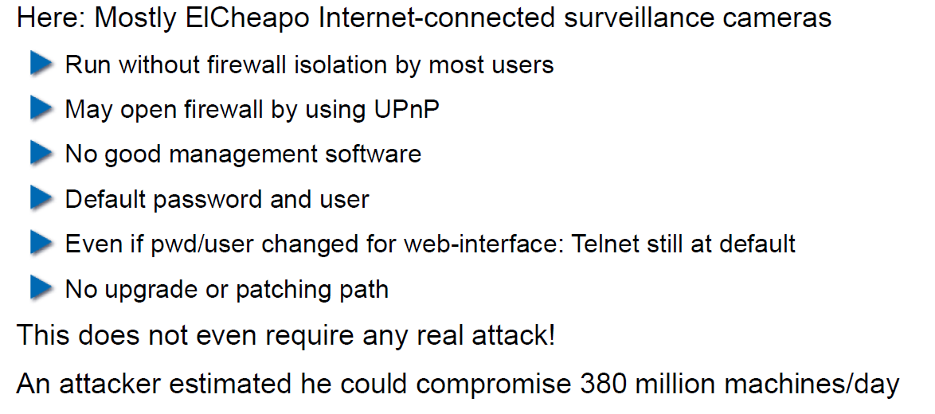

## Why are These IoT Devices so Insecure?

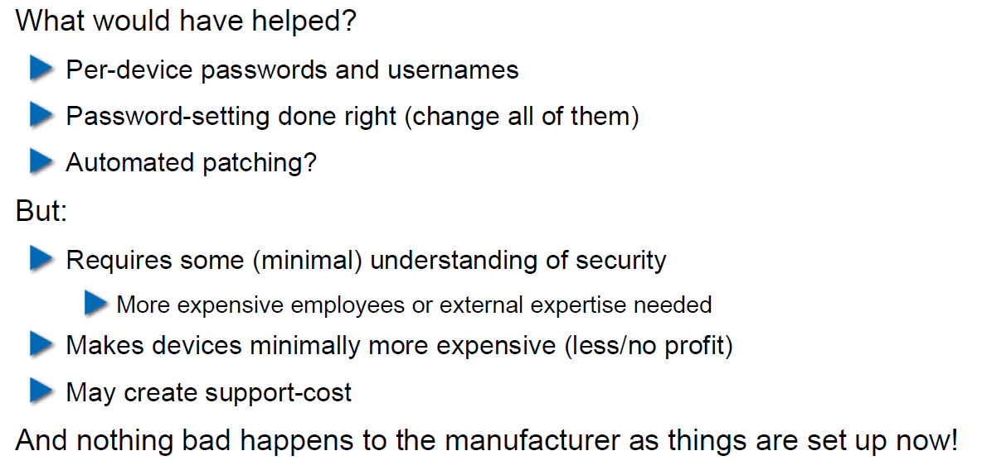

## Possible Solutions

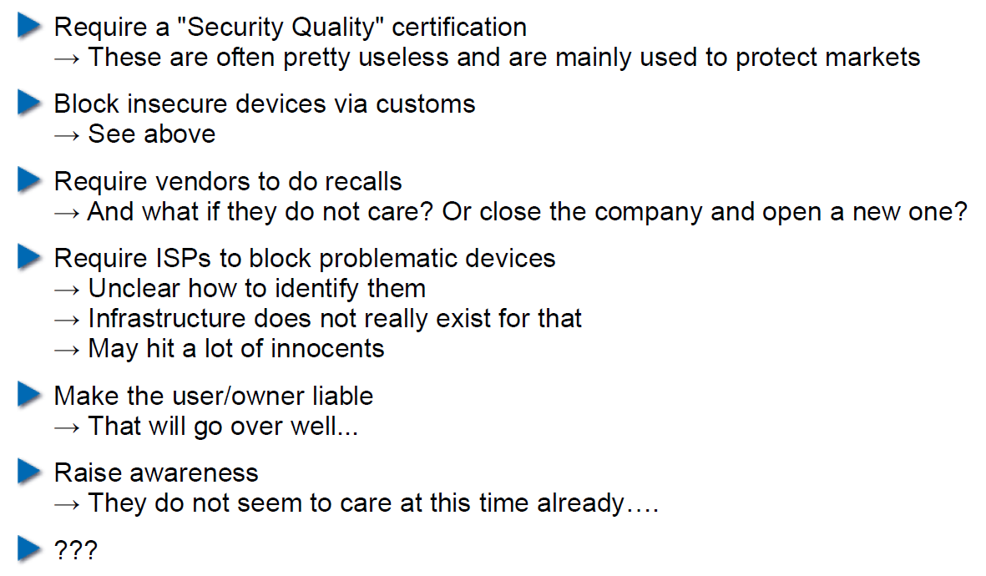

## Does it Pay to make Software Secure?

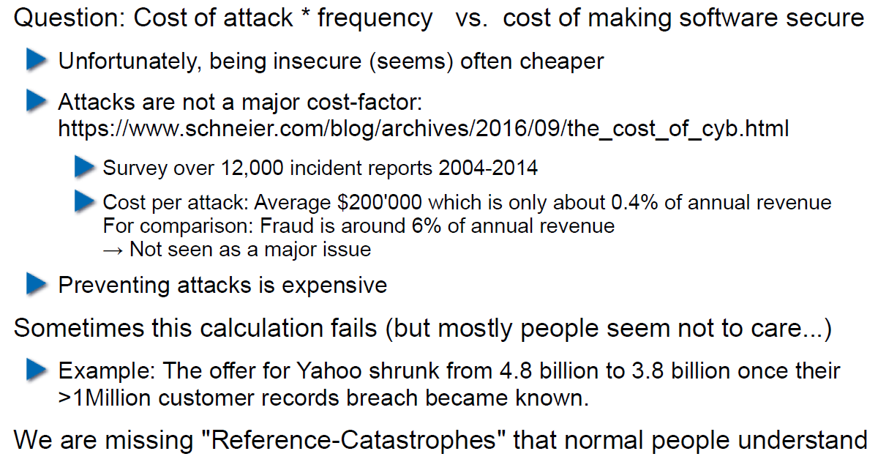

## So, what to do?

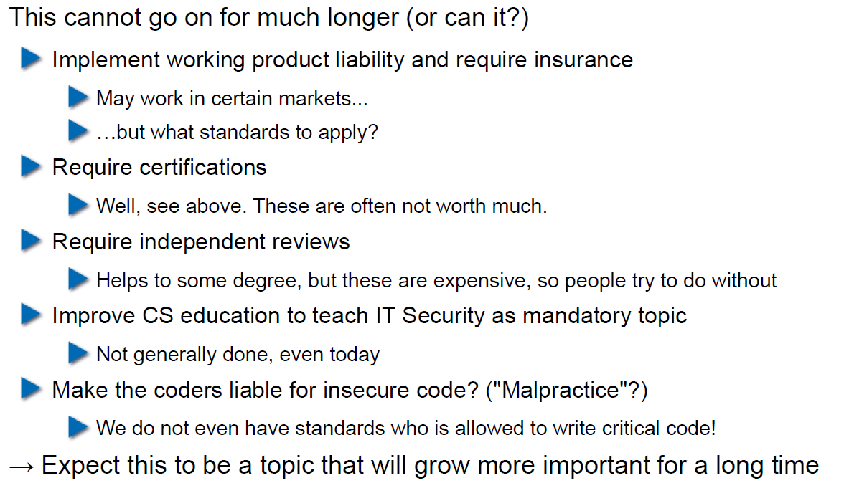

# Woche 5